**ITP MINI PROJECT**

**TIC-TAC-TOE(3X3)**

TEAM 18 – EE21B013 DIVYANSHU DWIVEDI

CS21B030 M VIDHYABHUSHAN

CE21B015 HIMANSHU YADAV

EE21B013 DEVARUPA GANESH SAI MANAS

CS21B033 MVS KARTHIKEYA

We made this game in python using pygame module.

This is a 3x3 tic tac toe version. The game starts with a

Welcome page having a start button and giving instructions for the game such as pressing ‘r’ to restart

a started game , ‘s’ for scores and start button to start

the game.

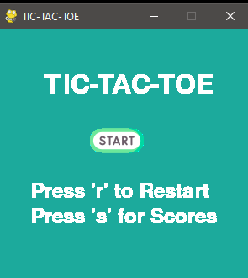

After pressing the start button game screen opens,

Where player 1 is circle and player 2 is cross.

You can play by clicking the space you want to insert in it

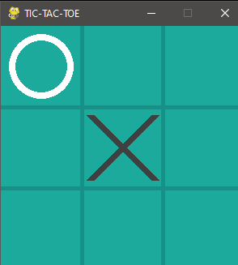

After a player wins or a draw ocuurs user can press ‘r’ to restart the game. Scores will be updated automatically.

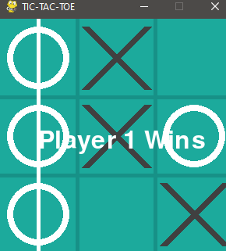

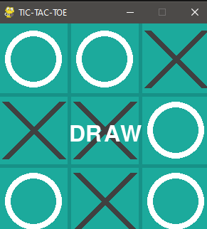

You can check scores by pressing the ‘s’ key, and play

Again by pressing the ‘g’ key. Or return to the main menu by pressing the ‘m’ key.

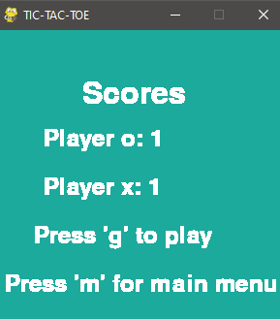

**CORE FUNCTIONS:**

Class Game() :- It defines information like board(2D array), playable moves, chances, fonts for text.

It has few functions like move, win, horizontal win line

Vertical win lines and diagonal wins.

1. Init(self) :- defining the board, chance, playable moves and fonts
2. Move(self, draw) :- updates the 2d array and changes chances
3. Win(self, player, screen) :- checks wins across horizontal, vertical and both diagonal wins.
4. Vertical_win_line(self, c, screen):- checks vertical win and draws vertical win line.
5. horizontal_win_line(self, c, screen):- checks horizontal win and draws horizontal win line.
6. diagonal_win_line(self, c, screen):- checks horizontal win and draws diagonal win line.
7. Other_diagonal_win_line(self, c, screen):- checks horizontal win and draws diagonal win line.

Class Draw() :- It defines entry for row and col, it helps in drawing the player figure.

Class Button() :- This class contains images and make them work as a button and help to draw button on screen.

1. Def init(self, r, c, image):- defines images and its destination.
2. Def draw(screen, destination):- it draws button image and checks if it is clicked and take to the destination function.

main() :- It has the game screen i.e. the pygame GUI window and it take cares of events occurring in the pygame window.

start() :- It defines the starting page the heading and a few instructions in form of strings and it take cares of events occurring in the pygame window.

draw_board(screen) :- It makes the board for the tic-tac-toe.

The grids , background.

player1(screen, r, c) :- It defines the structure of player 1 i.e. a circle.

player2(screen, r, c) :- It defines the structure if player 2 i.e. a cross of grey color.

make_move(screen, board) :- It checks if chance is of player 1 then “1” gets updated in the list in position selected and “2”

for player 2.

**Data Formats**

1. board = It is a 2D array having empty elements
2. playable moves = it is an array having all playable moves
3. player1 = it a bool variable to check chances.
4. Height, width = int variables dimensions of screen.
5. Cell size = int variable storing the size of each entry space.
6. Score_o, score_x = these int variables take care of scores.
7. Restart, head, scores = they are rendered fonts these help in printing strings we need to append on screen.
8. Font = this variable helps to specify font type with the help of inbuit function font() of pygame module.